Dear Parent/Carer,
Re: Homework
I wrote to you in September last year to update you about changes to homework. Since then, we have been working hard to encourage and support our students to complete their homework. I am writing to let you know about our next steps to support our students with this.
From Tuesday 16th April we will be opening and staffing a space for our students to complete their homework. There will be access to computers, printers, stationery, and knowledge organisers for our students to study in a quiet environment which is resourced with all they might need to be successful. We will also have a member of staff that is available to help students with any technical issues, advice or academic help.
We introduced weekly homework because studies show that a consistently implemented homework schedule will not only build on students' progress and better prepare students for the revision required in Key Stage 4, College and University studies but has proven to give an average of 5 months additional learning.
The tasks have been shared with your child via class charts, you are able to login see their homework schedule and completion dates, as well as how your child is doing in school. Below is a reminder of the information previously shared.
All KS3 students will receive one piece of homework for every subject they study each week. English, maths and science will set up to 30 minutes per week, other subjects 10 minutes per week. 10 minutes may not seem like much, but at KS3 students study 10 subjects in addition to maths, English and science, so this amounts to approximately 3 hours of additional study each week. Students will receive each of their pieces of homework on the same day each week, making this easier to manage. Their schedule for this year is below.
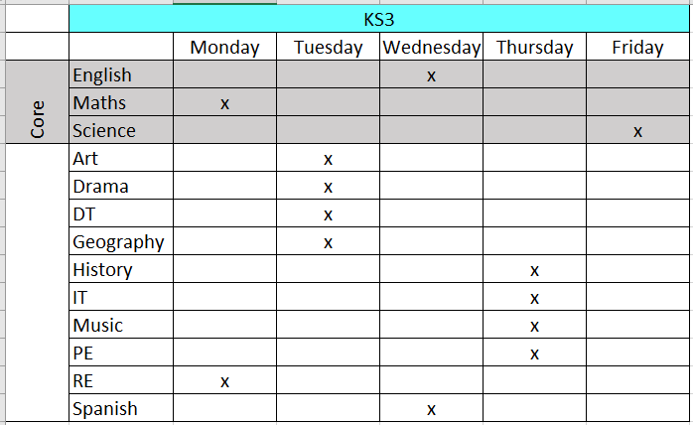
All KS4 students will receive one piece of homework for every subject each week of 30 minutes. At KS4 students study fewer subjects, but they are all examined GCSE or equivalent subjects. They will receive their homework on this same day each week. Their schedule is over the page.
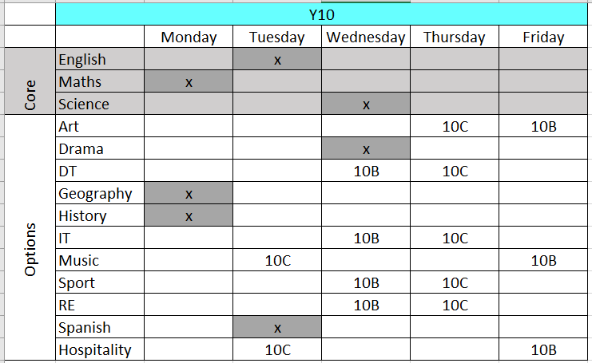

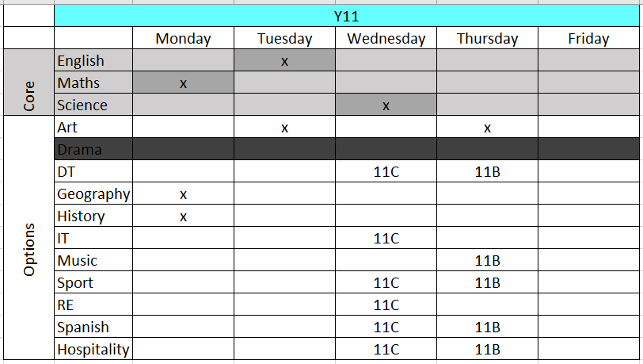
I’d like to thank you in advance for your continued support of Parkwood Academy. Should you have any questions regarding this letter please contact me in the first instance via email at alexandra.paine@pwa.e-act.org.uk or call the school reception and leave a message and I will get back to you at the earliest opportunity.
Kind Regards
Alexandra Paine
Assistant Headteacher (Curriculum)

